INFORMATION PACK FOR APPLICANTS

CONTENTS
- Advertisement Page 1-3
- Background note on the Police Investigations & Review Commissioner Page 3
- Organisational Structure Page 4
- Specific Duties Page 4-5
- Competencies Page 5
- Personal Specification Page 6-7
- Information about the Selection Process Page 7-8

1. AdVERtisement

VACANCY Administrator

SALARY £25,713 - £27,335 - A4
STAFF WILL BE APPOINTED ON POINT 1 OF THE SCALE- £25,713

STATUS Permanent

HOURS OF WORK Around 37 hours per week

LOCATION Hamilton – currently working to a hybrid model of office and home

The Police Investigations and Review Commissioner is currently seeking applications for an Administrator to join her team who are based in Hamilton.

The PIRC was established in 2013 and is responsible for carrying out independent investigations into incidents involving the police and independently review the way the police handle complaints from the public. Our aim is to secure public confidence in policing in Scotland by supporting continuous improvement and promoting positive change.

The successful candidate will provide support to the Review and Investigations team. This role encompasses a wide variety of tasks which require excellent administrative and organisational skills, attention to detail, accurate typing, including audio, and the ability to professionally handle difficult calls and correspondence.

The specific tasks of the role are set out at Section 4.

Successful candidates should have a good standard of general education (minimum SCQF level 6 or equivalent) including English or equivalent relevant qualification/proven experience in a similar role, minimum 1 year. They should also be able to evidence their abilities to meet the essential requirements for the post.

The PIRC offers 25 days of annual leave plus 5.5 privilege days, competitive pension and benefits and operates flexible working arrangements.

The position is based in Hamilton. The successful candidate must undergo Non Police Personnel Vetting (NPPV) Level 3 and Security Clearance (SC) prior to appointment. Please see here United Kingdom Security Vetting: Applicant - GOV.UK (www.gov.uk) to ensure you are aware of the requirements prior to submitting an application.

The PIRC is an equal opportunities employer and is committed to promoting a diverse workforce, with an emphasis on the PIRC values of integrity, impartiality and respect. We, therefore, encourage and welcome applications from all members of the community. We are committed to the Disability Confident Initiative and offer a guaranteed interview to any applicant who meets all of the selection criteria required for the post and considers themselves to be disabled.

For information on this vacancy please contact the Human Resources Department at jobs@pirc.gov.scot or call on 07342 080256.

How to Apply

The candidate Information Pack / Application Form is available from:

https://pirc.scot/about-us/work-with-us/vacancies/

Email: jobs@pirc.gov.scot

The closing date for applications is midnight on Sunday 30th July 2023

Shortlisting will take place thereafter. Successful applicants will be contacted with an interview date in due course.

Applicants who have not been contacted by us within 3 weeks of this closing date should assume they have been unsuccessful on this occasion. Please note we are unable to provide feedback on unsuccessful applications.

Only completed application forms will be considered. Please do not substitute your Curriculum Vitae for a completed form since this will not be considered.

2. Background note on the Police INVESTIGATIONS & rEVIEW COMMISSIONER

The Police Public Order and Criminal Justice (Scotland) Act 2006, as amended by the Police and Fire Reform (Scotland) Act 2012, sets out the functions of the Police Investigations & Review Commissioner (PIRC). These are to review the manner in which policing bodies in Scotland deal with complaints and also to conduct investigations into particular kinds of incidents involving the police. The types of investigation which the PIRC may carry out are specified in the 2006 Act, as amended.

The PIRC is a Non-Departmental Public Body (NDPB) sponsored by the Scottish Government. The organisation is led by the Commissioner, Michelle Macleod, who is supported by the SMT and a team of staff, based in Hamilton
3. ORGANISATIONAL STRUCTURE

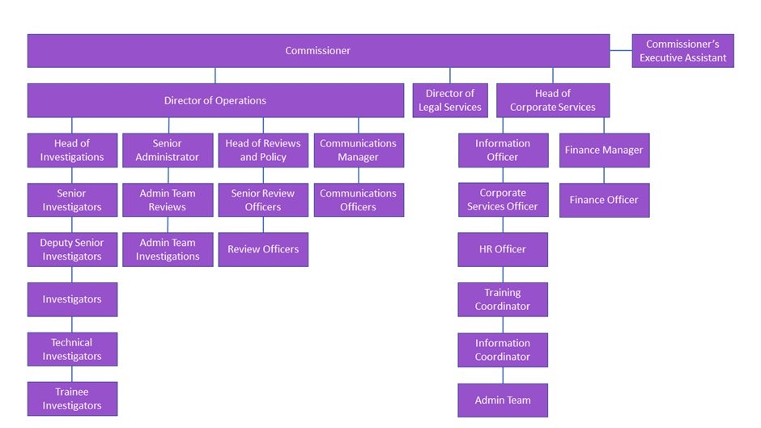

4. Specific duties

The specific duties of an Administrator are:

You will be required to:
- Deal with telephone and email enquiries that are often complex, challenging and difficult in nature.
- Deal with telephone and email enquiries
- Sort & distribute incoming/outgoing mail
- Carry out word processing, copy & audio typing, formatting and quality assuring reports and letters
- Process data and maintain databases.
- Format and issue Investigation reports including draft reports
- Assist in the regular audits of the case management system and produce various statistical reports
- Maintain filing systems, organise and store paperwork, documents and computer-based information, in accordance with our records management policy and ensure that data security and confidentiality is maintained at all times
- Take responsibility for logging and retention of PIRC productions
- Photocopy, print and scan various documents
- Organise appointments, meetings, travel and events
- Order and maintain stationery and equipment supplies
- Take minutes at meetings
- Process data and maintain databases
- Monitor all resource mailboxes and action appropriately
- Provide cover for admin team colleagues on all PIRC admin functions
- Undertake any other task as directed by the Commissioner or Line Manager in line with pursuance of PIRC objectives.

5. COMPETENCIES

- Ability to deal with challenging individuals

- Ability to communicate fluently, clearly and concisely both orally and in writing

- Ability to prioritise, self-manage and deliver work within agreed timescales

- Ability to maintain the highest level of confidentiality at all times

- Ability to work effectively in a team environment.

- Ability to demonstrate a capacity and willingness to learn and improve.

- Ability to work effectively with internal and external stakeholders.

6. PERSON SPECIFICATION

 | Essential | Desirable
Qualifications
- Good standard of general education – minimum (minimum SCQF level 6 or equivalent) including English or equivalent relevant qualification or proven experience in a similar role
- HNC in Business Administration or equivalent
Experience
- Proven experience (minimum 1 year) in an administrative role where ability to work on own initiative has been essential while at the same time contributing positively to team outcomes
- Proven experience in maintaining good working relationships with internal and external customers
- Experience in organising and applying administration systems and processes
- Experience in diary management, organising meetings and minute taking
- Experience of working in an environment where confidentiality and discretion are essential
Skills & Knowledge
- Ability to communicate fluently, clearly and concisely both orally and in writing with a wide variety of people and organisations
- Excellent customer service and interpersonal skills with the ability to deal effectively with sensitive or difficult situations
- Excellent organisational and self-management skills with ability to prioritise tasks and work to tight deadlines
- Good problem solving skills
- Excellent word processing and audio/copy typing skills being fully proficient with Microsoft Office, particularly Word, Excel, Outlook and PowerPoint
- Excellent attention to detail with a high level of accuracy in all work
- Team player who can also work on own initiative and under pressure to achieve positive results
- Knowledge of Adobe Acrobat
- Knowledge of Police, Public Order and Criminal Justice (Scotland) Act 2006 and/or Police and Fire Reform (Scotland) Act 2012

7. Information about the selection process

(a) Application process
In addition to this information pack, you should have:
An Application for Appointment form, which includes an Equal Opportunities recruitment monitoring form
Before competing and submitting your application form, you should give due consideration to the following:
Competency based evidence – are you familiar with what is being sought at the application stage and what will be sought at interview through the use of competency based questions and how you should evidence this.
Qualifications, Skills, Knowledge and Experience required – can you demonstrate the essential and desirable criteria outlined in the Person Specification.
Please ensure that you complete all sections of the job application form and that you return it by the date specified. We will be unable to consider your application if all sections are not fully completed. Completed Equal Opportunities recruitment monitoring data will be separated from the application form and will not be made available to the selection panel members. The information collected will be treated in the strictest confidence, and will only be used for the purpose of furthering the PIRC’s policy of equal opportunity. Your application is very important as it is the key document which will determine whether or not you will proceed through the first assessment stage to interview and ultimately to appointment. You must therefore demonstrate clearly the evidence required in your application form on how you meet the relevant published skills, knowledge and experience shown in the person specification. Please read the person specification in conjunction with the role description, competencies and all other information contained in this pack.
Please do not substitute your Curriculum Vitae for a completed form or attach your CV with your application as it will not be considered and your application form may be rejected.
A good application should be structured to ensure that it flows in a clear and/or logical way. You should provide evidence and examples to ensure that it is clear to the selection panel the actions you took, the reasons for your actions, what happened, what you took into account and the outcome.
You should not assume that the evidence provided is obvious when it comes to meeting the competency/criterion, for instance by simply recounting job titles or job duties. You should try and avoid bland and hypothetical statements and where possible/appropriate use the first person – “I” not “We”.
You should also be aware that on occasion there may be several ways in which we ascertain evidence of the skills, knowledge or experience sought, so please ensure you provide evidence that shows how you meet all aspects of the role.
You can apply online or submit hardcopy. If your application is handwritten, please use black ink and ensure it is legible as your form will be photocopied/scanned and then read by the selection panel.
We would advise you to keep a copy of your initial application for reference.

(b) How to return your Application
Email to: jobs@pirc.gov.scot
OR by post to: Human Resources, Police Investigations and Review Commissioner, Hamilton House, Hamilton Business Park, Caird Park, Hamilton, ML3 0QA
Closing date
The deadline for applications is midnight on Sunday 30th July 2023. Late applications will not be considered.
(c) Selection panel
You will be notified of the members of the selection panel if invited to interview.
(d) Selection
Your completed application form will be assessed against the requirements for the position. If you are successful at this initial selection stage, you will be invited to take part in the interview and any assessment process.
(e) What will happen at the interview?
During the interview process, the selection panel will ask your questions related to your career history and to the competencies required for the job. This will include the evidence you provided within your application form and from any written assessment, presentation or other appropriate exercise.
(f) What will happen following the interview?
All applicants invited to interview will be advised of the outcome of the appointments process in writing.
(g) What is the procedure if I am successful?
The successful applicant(s) will undergo a vetting process which can take approximately 3 months with a start date to follow this. We advise successful applicants not to notify their current employer of their notice until we confirm that this has been successfully completed.

